**Quick Start Tutorials: How to run a Negotiation session**

In this tutorial you will learn how to run a negotiation session. A negotiation session is a single negotiation in which two agents compete. This mode is mainly intended for new users.

There are two types of agents that can be used in a tournament:

* **Automated agents** – agents that can compete against other agents in a negotiation without relying on input from a user. In general, these agents are able to make a large amount of bids in a limited amount of time.
* **Non-automated agents** – agents that are fully controlled by the user. These types of agents ask the user each round which action they should make. Genius by default includes the UIAgent – which has a simple user interface – and the more extensive Extended UIAgent.

Select “**Start**” and then “**Negotiation Session**”. This opens a window similar to the figure below.

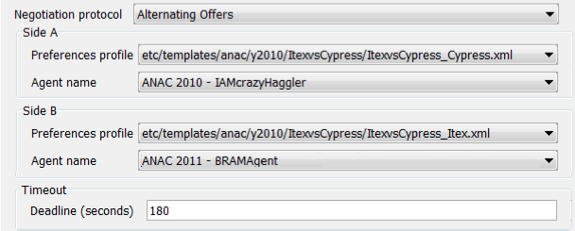

The following parameters need to be specified to run a negotiation:

• **Negotiation protocol** – the set of available protocols (normally “Alternating Offers” is used)

• **Side A/Side B** – the configuration of the agents on both sides

• **Preference profile** -the preference profile to be used by the agent of that side.

• **Agent name** – the agent participating in the negotiation

• **Deadline (seconds)** - the length of the negotiation in seconds

Select start to begin the negotiation.